BURTLE ANNUAL PARISH MEETING

Wednesday 7th April 2021 at 8.00pm

This is a meeting of the Parish which must be held each year and all electors of the parish are invited to take part and raise points for discussion. In view of current Covid 19 regulations this meeting will be held via zoom.

Joining details are available from the clerk at burtlepc@gmail.com

AGENDA

1 Apologies

2 Chairman’s Report

3 Financial Report

4 District Councillor’s Report

5 County Councillor’s Report

6 Reports from Organisations:

7 Items for discussion

8 Any other business

10 Close of meeting.

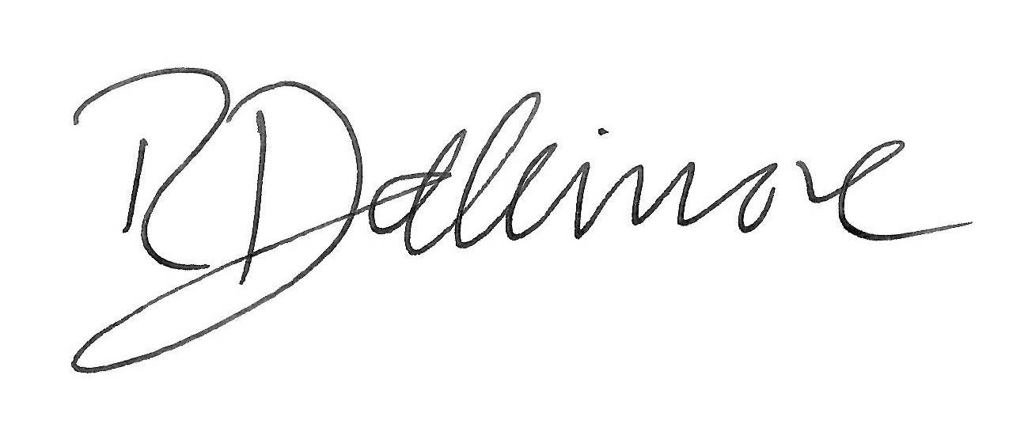

Richard Dallimore
Chairman Burtle Parish Council

